Communication and Language  In small groups we will talk about different celebrations and festivals e.g., birthdays, Bonfire Night, Diwali and Christmas. This will involve listening to the stories for these festivals.  It is Nursery Rhymes Week the week of the 13th November. We will be learning new rhymes and singing our favourites.  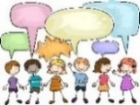  We will be starting our WellComm groups. These will involve working on your child’s next steps in their communication and language.  Specific vocabulary related to our themes and events is introduced to the children each week. | Personal, Social and  Emotional Development  We will be continuing to help and support the children with sharing and taking turns. We will play games indoors and outdoors to work on these skills.  We will be learning about different emotions, introducing the children to different feelings, recognising them and using the different language e.g., happy, excited, surprised, sad, angry, cross, scared, frightened etc.. | Physical Development  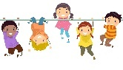  We are continuing to develop our gross motor skills such as running, jumping, climbing and balancing through a range of activities including big group games and playing on the climbing equipment. We play outside every day. The children will have the opportunity to take part in large scale painting and drawing indoors and outdoors.  We are developing our fine motor skills through threading, drawing, mark making and painting.  We are now able to put on our own coats. We will now learn how to fasten them ourselves and put on our hats. | Literacy  We will continue to develop our early literacy skills through, recognising our name on our coat pegs and name cards. Also, through reading labels and vocabulary in our indoor and outdoor environment.  We will continue to take part in independent, small group and family group reading time where we will be reading a range of books (fiction & non-fiction). E.g., The Diwali and Christmas story and nursery rhymes.  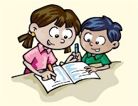  We will continue to take part in mark making, there are many opportunities across the environment e.g., writing a message, name writing, writing invitations, cards and shopping lists in the home corner.
Alongside our half termly themes we promote learning through the ‘Planning in the Moment’ programme by Anna Ephgrave which allows children to lead their play and learning. We plan learning which extends on each child’s ideas. | 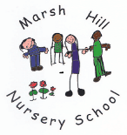  Autumn 2  Festivals, Celebrations & Nursery Rhymes
Mathematics  Mathematics is everywhere and we do it every day without even realising!!  We will continue to follow daily routines, singing counting songs and rhymes, playing games, recognising numbers and shapes in the environment, and counting how many children are in the family group each day.  We will also be learning to count objects accurately and say how many there are altogether. |  |  | Characteristics of Effective Teaching and Learning  This term we are focusing on:  Playing & Exploring  Active Learning  Creating & Thinking Critically  Look out on Tapestry to see your child taking part in a variety of activities to develop these important characteristics.
 | Expressive Arts and Design  We will be taking part in weekly specialist music lessons with our music teacher from the Music Service.  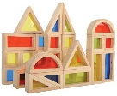  We will continue to take part in a range of different activities to develop our expressive arts and design skills. These will involve; building models with the different construction kits, role play in our home corner, painting and collage activities in our creative area. | Understanding the World  We will be learning about different festivals and celebrations including Bonfire Night, birthdays, Diwali and Christmas through circle time, reading stories, speaking and listening activities, games and creative activities.  We will learn that we can share celebrations and we can celebrate different events at different times of the year.  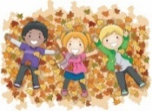  We will continue to take part in our Forest Fun activities. These will include making bird feeders, recognising different birds, beginning to learn their names and enjoying some hot chocolate!

